**Develop a linear regression model for forecasting time series data for the given dataset**

**EX.No:4**

**DATE:**

**AIM:**

To develop a Linear Regression model for forecasting future values in a time series dataset by analyzing historical trends. The goal is to provide a simple, interpretable approach to predict upcoming data points based on time-dependent patterns.

**ALGORITHM:**

1. Load data, explore for missing values and target variable distribution.
2. Clean data, handle missing entries, remove duplicates, address outliers, convert 'DATE_TIME'.
3. Create lagged, time-based, and rolling window features.
4. Split data into training, validation, and test sets, keeping temporal order.
5. Train a linear regression model, evaluate using MAE, RMSE, and R2 on validation data.
6. Evaluate model on test data, deploy for predictions on new data.

**CODE:**

import pandas as pd

from IPython.display import display

df = pd.read_csv('Plant_1_Generation_Data.csv')

display(df.head())

print(df.dtypes)

print(df.isnull().sum())

print(df['AC_POWER'].describe())

import matplotlib.pyplot as plt

df['DATE_TIME'] = pd.to_datetime(df['DATE_TIME'])

plt.figure(figsize=(12, 6))

plt.plot(df['DATE_TIME'], df['AC_POWER'])

plt.xlabel('Date and Time')

plt.ylabel('AC Power')

plt.title('AC Power Over Time')

plt.show()

numerical_df = df.select_dtypes(include=['number'])

correlation_matrix = numerical_df.corr()

print(correlation_matrix['AC_POWER'].sort_values(ascending=False))

df['DATE_TIME'] = pd.to_datetime(df['DATE_TIME'])

print("Missing values:\n", df.isnull().sum())

print("\nDuplicate timestamps:", df.duplicated(subset=['DATE_TIME']).sum())

df = df.sort_values('DATE_TIME')

df = df.drop_duplicates(subset=['DATE_TIME'], keep='first')

Q1 = df['AC_POWER'].quantile(0.25)

Q3 = df['AC_POWER'].quantile(0.75)

IQR = Q3 - Q1

lower_bound = Q1 - 1.5 * IQR

upper_bound = Q3 + 1.5 * IQR

df = df[(df['AC_POWER'] >= lower_bound) & (df['AC_POWER'] <= upper_bound)]

df = df.set_index('DATE_TIME')

df['AC_POWER_lag_1d'] = df['AC_POWER'].shift(24)

df['AC_POWER_lag_2d'] = df['AC_POWER'].shift(48)

df['AC_POWER_lag_7d'] = df['AC_POWER'].shift(168)

df['day_of_week'] = df.index.dayofweek

df['month'] = df.index.month

df['year'] = df.index.year

target = 'AC_POWER'

df['rolling_mean_7d'] = df['AC_POWER'].rolling(window=168).mean()

df = df.dropna()

from sklearn.model_selection import train_test_split

X = df.drop('AC_POWER', axis=1)

y = df['AC_POWER']

X_train, X_test, y_train, y_test = train_test_split(X, y, test_size=0.2, shuffle=False)

X_train, X_val, y_train, y_val = train_test_split(X_train, y_train, test_size=0.2, shuffle=False)

from sklearn.linear_model import LinearRegression

X_train = X_train.select_dtypes(include=['number'])

X_val = X_val.select_dtypes(include=['number'])

model = LinearRegression()

model.fit(X_train, y_train)

y_pred_val = model.predict(X_val)

from sklearn.metrics import mean_absolute_error, mean_squared_error, r2_score

import numpy as np

mae = mean_absolute_error(y_val, y_pred_val)

mse = mean_squared_error(y_val, y_pred_val)

rmse = np.sqrt(mse)

r2 = r2_score(y_val, y_pred_val)

print("Mean Absolute Error (MAE):", mae)

print("Root Mean Squared Error (RMSE):", rmse)

print("R-squared (R2) Score:", r2)

import matplotlib.pyplot as plt

plt.figure(figsize=(12, 6))

plt.plot(y_val.index, y_val, label='Actual')

plt.plot(y_val.index, y_pred_val, label='Predicted')

plt.xlabel('Date and Time')

plt.ylabel('AC Power')

plt.title('Actual vs. Predicted AC Power')

plt.legend()

plt.grid(True)

plt.show()

**OUTPUT:**

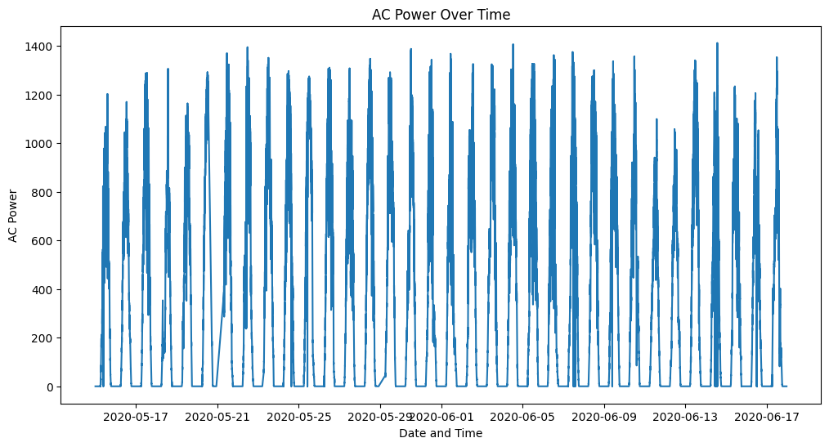

**RESULT:**

Thus the program has been completed and verified successfully.